Image Retrieval using Pretrained Model Convolutional Neural Network Feature Extraction for Skin Cancer Dataset

Ela Efriyanti, Aaliyah Lusianti

*Muhammadiyah Malang, University, Jl. Raya Tlogomas No. 246, Malang, 65144, Jawa Timur, Indonesia.*

*Tel.: 0341 464318, Fax: (0341) 460435*

# Abstract

Skin cancer is a dangerous and deadly disease that can attack humans. Early detection of skin cancer is the initial stage of preventing the disease from spreading to a serious stage. Content-based Image Retrieval (CBIR) is an image recognition system by entering an image query which is then matched with the dataset by calculating the similarity of images in the dataset with the given image query. Classification of skin cancer with its types will make it easier to detect the type of skin cancer expe- rienced. The Convolutional Neural Network method which was applied to the ISIC 2018 skin cancer image dataset using pretrained VGG16, Resnet50, and EfficientNet resulted in excellent performance.

*Keywords:* Skin Cancer, CBIR, Classification, Image Dataset, VGG, ResNet, EfficientNet

# Introduction

Image retrieval in the medical world has expanded thanks to technological advances that occur in this era, including diseases such as skin cancer [1][2]. Skin cancer is one of the most common types of cancer worldwide [3]. Easy to treat when detected in its early stages [4]. Melanoma is the most dangerous form of Skin cancer. Early detection of melanoma is important in reducing skin cancer mortality. Recently, machine learning has become an efficient method of classifying skin lesions as melanoma or benign [5] [6]. In the context of dermatology, CBIR can aid diagnosis by comparing visually similar features of skin lesions [7][8]. The Content-Based Dermatological Lesion Retrieval (CBDLR) system retrieves a query of skin lesion images that are similar to the image dataset and their diagnosis to be classified into the dataset class[8]. With the intuitive support of experienced dermatologists, early diagnosis via this CBDLR screening significantly improves patient survival, while reducing treatment costs [1].

The diagnosis of skin cancer is an area where clarity is critical because lesions of different classes often exhibit confusing characteristics [9]. This work proposes a deep neural network (DNN) [10] for skin cancer diagnosis that provides explanation through content-based image capture [11]. We explore several cutting-edge approaches to increasing the feature space studied by DNNs, namely contrastive, distillation, and triplet loss [12]. Image is an image on a plane two dimensions and is a continuous function of light intensity in a two-dimensional plane. Source light illuminates objects, objects reflect back part of the light beam. this reflection of light captured by optical instruments, such as the eye on the humans, cameras, scanners and so on, the shadow of the object is the recorded image [13][14].

Before the CBIR system is implemented it is necessary process so that image data can be recognized by computer and the value is calculated so that the system can sort and classify images have similarities [15]. One of deep's algorithms learning in this study used, namely convolutional neural network (CNN) as a process feature extraction and to perform comparisons use the euclidean distance formula [16].

Based on the results of the pre-pilot study, the researcher decided to use 40 randomly selected query images from 1021 images in our data set: 20 without CBIR and 20 with CBIR. Results with a significant change in accuracy where P < 0.05 between the two conditions are shown in bold, indicating that the accuracy of classifying images of nevus and MM increases significantly with CBIR [7].

The Derma-CBIR system tested on a dataset of a total of 240 lesions (20 images per category) achieved a mean recall of 0.921, a precision of 0.875 and a rating of 0.081. The results obtained indicate that Derma-CBIR is effective when compared to other advanced CBIR systems [17]. The CBDLR system has been exhaustively evaluated using the challenging ISIC2018 [1][18] and ISIC2019 datasets [19], and the results obtained suggest that the proposed system can provide useful assisted decisions while offering advantages model. The highest precision and recall results in the Resnet model are 97% [1].

From the previous research that has been mentioned, we propose a content-based image retrieval technique using similarity measurement by calculating the Eucledian distance in the ISIC 2018 dataset using 3 CNN pretrained models including VGG16, ResNet50 and EfficientNet to find out greater performance as a contribution from previous studies, especially in the resulting measure of precision and recall.

# Method

* 1. Dataset

The dataset used in this study was obtained from an open source Kaggle entitled ISIC 2018 [1] which is skin cancer data with 7 disease classes in- cluding Melanotic Nevi, Melanoma, Benign Keratosis, Basal Cell Carcinoma, Actinic Keratoses, Vascular Lesions and Dermatofibromas [20]. The to- tal number of data is 10015 images. Figure 1 is an example of a skin cancer dataset display that has been preprocessed with a resize of 32 x 32 pixels. We do data splitting by dividing 80% for training data, 19% for testing data and 1% for data validation.

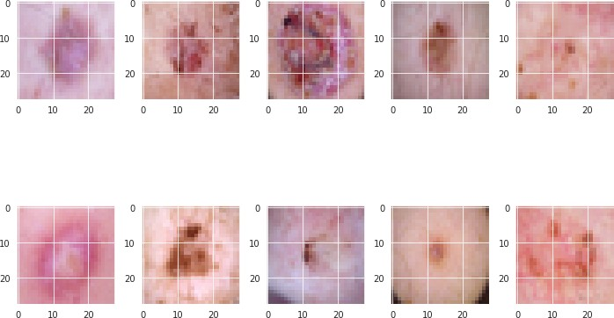

Figure 1: Fig. 1. Display of International Skin Imaging Collaboration 2018 dataset.

* 1. *Preprocessing*

This stage begins by resampling the data with the Random Over Sampling technique because the dataset used is an imbalance dataset [21][22][23]. The splitting process on the data is divided into 8112 images as training data, 1903 as testing data and the remaining 101 images as validation data. Figure 2 shows the total number of each class in the dataset. The number labels on the plots are 0 : Actinic keratosis, 1 : Basal Cell Carci- noma, 2: Benign Keratosis, 3: Dermatofibroma, 4: Melanocytic Nevi, 5: Vascular Lesion and 6: Melanoma [24]. Then in Figure 3 shows the results of data balancing using the Random Over Sampler technique, namely by balancing the dataset class using the highest number of class images.

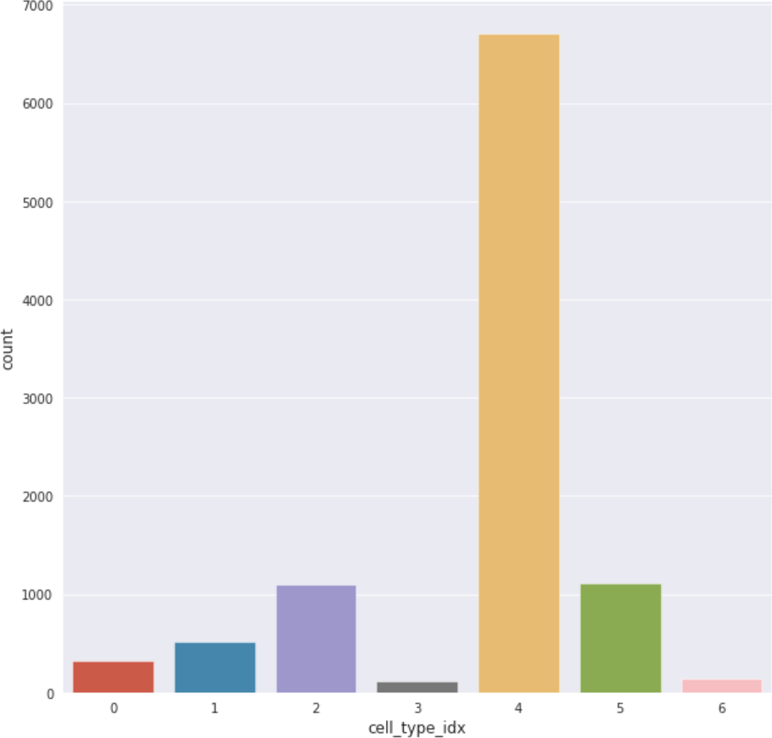

Figure 2: Plot Count of Imbalance Dataset

* 1. *Feature Extraction*

In the next stage, we use the convolutional neural network method with pretrained models [25]

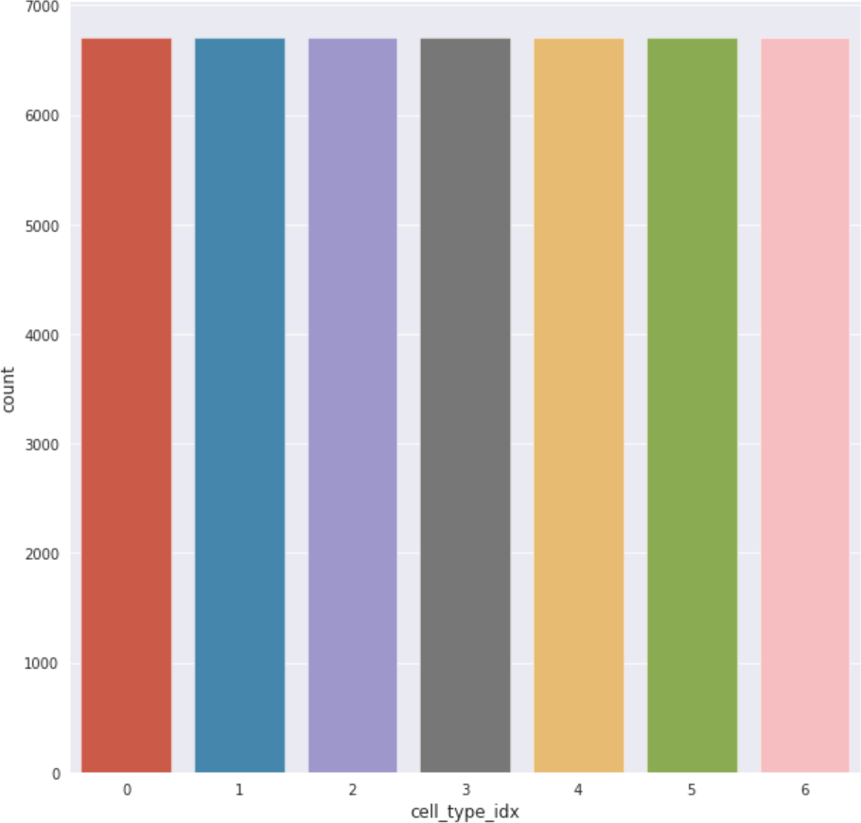

Figure 3: Plot count of Balanced Dataset

of the types VGG16, Resnet50v2 and EfficietNetB5. Each pretrained model uses 5 layer models with an input size of 32 x 32 pixels. The layer model used is Global Max Pooling with Dropout 0.35, activation ReLu and softmax. We use softmax activation because the dataset used consists of 7 disease classes, so the type of loss used is Cat- egorical Cross Entropy from the Keras library. The learning rate value used for each pretrained model is 0.0001 with the Adam type optimizer. When running the epoch 100 times, we initialize the Reduce Learning Rate on Plateau in the callback when compiling the model.

# Experimental Result

The results obtained from the 3 pretrained models, Resnet has better accuracy results with 99% accuracy (table 1), 100% precision and 100% recall (table 2) in 5 classes including Melanotic Nevi, Melanoma, Basal Cell Carcinoma, Actinic Keratoses and Vascular Lesions. The highest pre- cision and recall are in the actinic keratosis class with 100% precision, 100% recall and 100% f1- score. Average of precision is 0.99, average recall 0.96 and 0.97. Table 1 shows the results of the model evaluation in the form of accuracy values for each pretrained model.

Table 2 shows the results of precision, recall and f1-score obtained for the best model, namely Resnet 50. Table 3 shows the results of 100% precision, 100% recall and the best 100% f1-score of the VGG16 model, namely Benign Keratosis, Melanoma and Actinic Keratoses. . While the EfficientNet model with the lowest model perfor- mance shows the highest precision value, 86%, re- call 98% and f1-score 92% in the Melanotic Nevi class in table 4.

The prediction result of the similarity of one query image (Figure 4) given to the dataset shows 12 images with the highest similarity shown in Figure 5 using the pretrained ResNet50 model as the best convolutional neural network model.

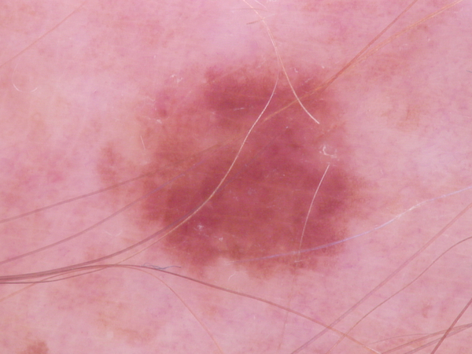

Figure 4: Query Image

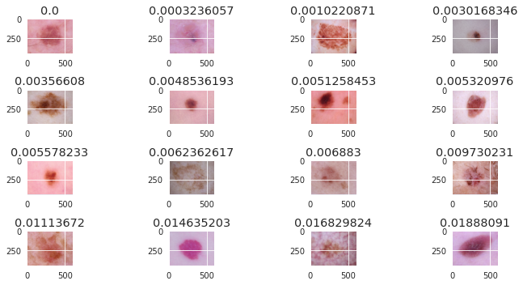

Figure 5: Top 12 Image Similarity

From the proposed model, we summarize the performance of several previous studies on CBIR which are shown in Table 5.

Graphic loss and accuracy shown in figure 5.

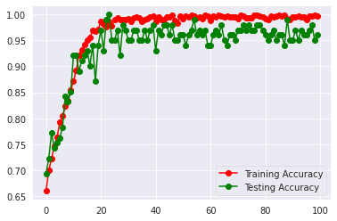

Figure 6 : Graphic Accuracy

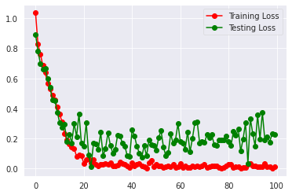

Figure 7 : Graphic Loss

# Conclusion

Skin cancer is a disease that is now often found in various parts of the world. This disease is clas- sified as a dangerous and deadly disease. Sev- eral types of skin cancer found in the ISIC 2018 dataset include Melanotic Nevi, Melanoma, Be- nign Keratosis, Basal Cell Carcinoma, Actinic Keratoses, Vascular Lesions and Dermatofibro- mas. From the seven classes, after the modeling process was carried out to find the closest similar- ity to the query image, it can be concluded that of the three convolutional neural network models, the ResNet50 model is the best model with an ac- curacy of 99%, 100% precision, 100% recall and f1-score 100. % with 4 disease classes.

# References

[1] W. Barhoumi and A. Khelifa, “Skin lesion image retrieval using transfer learning-based approach for query-driven distance recommendation,” *Comput. Biol. Med.*, vol. 137, no. August, p. 104825, 2021, doi: 10.1016/j.compbiomed.2021.104825.

[2] P. Kurian and V. Jeyakumar, *Multimodality medical image retrieval using convolutional neural network*. Elsevier Inc., 2020.

[3] I. Bakkouri and K. Afdel, “Computer-aided diagnosis (CAD) system based on multi-layer feature fusion network for skin lesion recognition in dermoscopy images,” *Multimed. Tools Appl.*, vol. 79, no. 29–30, pp. 20483–20518, 2020, doi: 10.1007/s11042-019-07988-1.

[4] E. D. Carvalho *et al.*, “Breast cancer diagnosis from histopathological images using textural features and CBIR,” *Artif. Intell. Med.*, vol. 105, no. February, p. 101845, 2020, doi: 10.1016/j.artmed.2020.101845.

[5] T. C. Pham *et al.*, “A Comparative Study for Classification of Skin Cancer To cite this version : HAL Id : hal-03025957 A comparative study for classification of skin cancer,” 2020.

[6] Y. Filali, H. EL Khoukhi, M. A. Sabri, and A. Aarab, “Efficient fusion of handcrafted and pre-trained CNNs features to classify melanoma skin cancer,” *Multimed. Tools Appl.*, vol. 79, no. 41–42, pp. 31219–31238, 2020, doi: 10.1007/s11042-020-09637-4.

[7] M. Sadeghi, P. Chilana, J. Yap, P. Tschandl, and M. S. Atkins, “Using content-based image retrieval of dermoscopic images for interpretation and education: A pilot study,” *Ski. Res. Technol.*, vol. 26, no. 4, pp. 503–512, 2020, doi: 10.1111/srt.12822.

[8] “Br J Dermatol - 2018 - Tschandl - Diagnostic accuracy of content‐based dermatoscopic image retrieval with deep.pdf.” .

[9] K. R. Kruthika, Rajeswari, and H. D. Maheshappa, “CBIR system using Capsule Networks and 3D CNN for Alzheimer’s disease diagnosis,” *Informatics Med. Unlocked*, vol. 14, no. August 2018, pp. 59–68, 2019, doi: 10.1016/j.imu.2018.12.001.

[10] P. Tschandl *et al.*, “Human–computer collaboration for skin cancer recognition,” *Nat. Med.*, vol. 26, no. 8, pp. 1229–1234, 2020, doi: 10.1038/s41591-020-0942-0.

[11] B. Muharom, H. Hidayat, and R. E. Putra, “Penerapan CNN dengan Filter Gabor sebagai feature extractor untuk Content-Based Image Retrieval,” *J. Informatics Comput. Sci.*, vol. 1, no. 1, pp. 16–25, 2019.

[12] C. Barata and C. Santiago, “Improving the Explainability of Skin Cancer Diagnosis Using CBIR,” *Lect. Notes Comput. Sci. (including Subser. Lect. Notes Artif. Intell. Lect. Notes Bioinformatics)*, vol. 12903 LNCS, pp. 550–559, 2021, doi: 10.1007/978-3-030-87199-4_52.

[13] T. S. Warongan, S. R. U. A. Sompie, A. Jacobus, T. Elektro, F. Teknik, and U. S. Ratulangi, “Penerapan Metode Content-Based Image Retrieval untuk Pengenalan Jenis Bunga,” *J. Tek. Inform.*, vol. 13, no. 3, 2018, doi: 10.35793/jti.13.3.2018.28070.

[14] A. Yilmaz, M. Kalebasi, Y. Samoylenko, M. E. Guvenilir, and H. Uvet, “Benchmarking of Lightweight Deep Learning Architectures for Skin Cancer Classification using ISIC 2017 Dataset,” 2021, [Online]. Available: http://arxiv.org/abs/2110.12270.

[15] F. Baig *et al.*, “Boosting the Performance of the BoVW Model Using SURF–CoHOG-Based Sparse Features with Relevance Feedback for CBIR,” *Iran. J. Sci. Technol. - Trans. Electr. Eng.*, vol. 44, no. 1, pp. 99–118, 2020, doi: 10.1007/s40998-019-00237-z.

[16] N. R. Hanggara, R. K. Niswatin, and P. Kasih, “Penerapan Content Based Image Retrieval Untuk Pengenalan Jenis Ikan Koi,” *Semin. Nas. Inov. Teknol.*, pp. 213–218, 2021.

[17] Q. Abbas, “Content-based Image Retrieval System for clinical diagnosis of Pigmented Skin Lesions,” *Int. J. Comput. Sci. Netw. Secur.*, vol. 17, no. 5, pp. 238–244, 2017.

[18] I. Razzak and S. Naz, “Unit-vise: Deep Shallow Unit-Vise Residual Neural Networks with Transition Layer For Expert Level Skin Cancer Classification,” *IEEE/ACM Trans. Comput. Biol. Bioinforma.*, vol. 14, no. 8, 2020, doi: 10.1109/TCBB.2020.3039358.

[19] T. T. Dat *et al.*, “Ensembled Skin Cancer Classification (ISIC 2019 Challenge Submission),” pp. 1–5, 2019, [Online]. Available: https://challenge2019.isic-archive.com/.

[20] M. A. A. Milton, “Automated Skin Lesion Classification Using Ensemble of Deep Neural Networks in ISIC 2018: Skin Lesion Analysis Towards Melanoma Detection Challenge,” 2019, [Online]. Available: http://arxiv.org/abs/1901.10802.

[21] J. Zhang and L. Chen, “Clustering-based undersampling with random over sampling examples and support vector machine for imbalanced classification of breast cancer diagnosis,” *Comput. Assist. Surg.*, vol. 24, no. sup2, pp. 62–72, 2019, doi: 10.1080/24699322.2019.1649074.

[22] Y. Pang, Z. Chen, L. Peng, K. Ma, C. Zhao, and K. Ji, “A signature-based assistant random oversampling method for malware detection,” *Proc. - 2019 18th IEEE Int. Conf. Trust. Secur. Priv. Comput. Commun. IEEE Int. Conf. Big Data Sci. Eng. Trust. 2019*, pp. 256–263, 2019, doi: 10.1109/TrustCom/BigDataSE.2019.00042.

[23] M. A. Kassem, K. M. Hosny, and M. M. Fouad, “Skin Lesions Classification into Eight Classes for ISIC 2019 Using Deep Convolutional Neural Network and Transfer Learning,” *IEEE Access*, vol. 8, pp. 114822–114832, 2020, doi: 10.1109/ACCESS.2020.3003890.

[24] M. Z. Alom, T. Aspiras, T. M. Taha, and V. K. Asari, “Skin Cancer Segmentation and Classification with NABLA-N and Inception Recurrent Residual Convolutional Networks,” 2019, [Online]. Available: http://arxiv.org/abs/1904.11126.

[25] A. Simran, P. . Shijin Kumar, and S. Bachu, “Content Based Image Retrieval Using Deep Learning Convolutional Neural Network,” *IOP Conf. Ser. Mater. Sci. Eng.*, vol. 1084, no. 1, p. 012026, 2021, doi: 10.1088/1757-899x/1084/1/012026.

Table 1: Accuracy of each model CNN

|  |  |  |  |
| --- | --- | --- | --- |
| No. | Model Name | Accuracy | Loss |
| 1 | Resnet50 | 0.99 | 0.07 |
| 2 | VGG16 | 0.96 | 0.22 |
| 3 | EfficientNet | 0.81 | 0.84 |

Table 2: Precision, Recall and F1-Score for Resnet Model

|  |  |  |  |  |
| --- | --- | --- | --- | --- |
| No. | Class of Skin Cancer | Precision | Recall | F1-Score |
| 1 | Melanotic Nevi | 1.00 | 1.00 | 1.00 |
| 2 | Melanoma | 1.00 | 1.00 | 1.00 |
| 3 | Benign Keratosis | 0.93 | 1.00 | 0.96 |
| 4 | Basal Cell Carcinoma | 1.00 | 1.00 | 1.00 |
| 5 | Actinic Keratoses | 1.00 | 1.00 | 1.00 |
| 6 | Vascular Lesion | 1.00 | 1.00 | 1.00 |
| 7 | Dermatofibroma | 1.00 | 0.75 | 0.86 |

Table 3: Precision, Recall and F1-Score for VGG16 Model

|  |  |  |  |  |
| --- | --- | --- | --- | --- |
| No. | Class of Skin Cancer | Precision | Recall | F1-Score |
| 1 | Melanotic Nevi | 0.98 | 0.97 | 0.98 |
| 2 | Melanoma | 1.00 | 1.00 | 1.00 |
| 3 | Benign Keratosis | 1.00 | 1.00 | 1.00 |
| 4 | Basal Cell Carcinoma | 0.75 | 1.00 | 0.86 |
| 5 | Actinic Keratoses | 1.00 | 1.00 | 1.00 |
| 6 | Vascular Lesion | 1.00 | 0.88 | 0.93 |
| 7 | Dermatofibroma | 1.00 | 0.75 | 0.86 |

Table 4: Precision, Recall and F1-Score for EfficientNet Model

|  |  |  |  |  |
| --- | --- | --- | --- | --- |
| No | Class of Skin Cancer | Precision | Recall | F1-Score |
| 1 | Melanotic Nevi | 0.86 | 0.98 | 0.92 |
| 2 | Melanoma | 0.00 | 0.00 | 0.00 |
| 3 | Benign Keratosis | 0.88 | 0.54 | 0.67 |
| 4 | Basal Cell Carcinoma | 0.62 | 0.83 | 0.71 |
| 5 | Actinic Keratosis | 0.00 | 0.00 | 0.00 |
| 6 | Vascular Lesion | 0.67 | 0.25 | 0.36 |
| 7 | Dermatofibroma | 0.75 | 0.75 | 0.75 |

Table 5: Comparison CBIR Model

|  |  |  |  |  |
| --- | --- | --- | --- | --- |
| No | Author | Accuracy | Precision | Recall |
| 1 | Barhoumi, et. al[1] | - | 0.97 | 0.97 |
| 2 | Screnario 1 – VGG16 | 0.96 | 0.96 | 0.94 |
| 3 | Scenario 2 – ResNet (propose method) | 0.99 | 0.99 | 0.96 |
| 4 | Scenario 3 - EfficientNet | 0.81 | 0.54 | 0.47 |